Let  be the N number of CITY entries in **STATION**, and let N’ be the number of distinct CITY names in **STATION**; query the value of N-N’ from **STATION**. In other words, find the difference between the total number of CITYentries in the table and the number of distinct CITY entries in the table.

**Input Format**

The **STATION** table is described as follows:

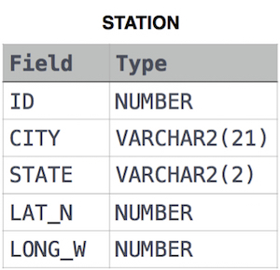

where LAT_N is the northern latitude and LONG_W is the western longitude

Solution:

SELECT COUNT(CITY)- COUNT(DISTINCT CITY)

FROM STATION;